Network Layer: Routing Algorithms,
Ethernet, Congestion Control & Internetworking
Week 4 — Study Notes
Course: Computer Networks
Generated Study Notes — Beginner-Friendly Edition
Compiled from lecture slides:
Week-4.pptx • Week-4_1_NetworkAlgorithms.ppt

Table of Contents

Chapter 1: Ethernet, Fast Ethernet, and Gigabit Ethernet

1.1 Why Did We Need Faster Ethernet?
Ethernet is a popular technology used to connect computers in a Local Area Network (LAN). A LAN is a network that covers a small area, such as one office or one building. In the early days, Ethernet was fast enough. But as more computers joined networks and people began sending larger files, the old Ethernet speed became too slow.
Definition: Ethernet is a set of rules (a protocol) that decides how computers send data over a shared cable or wire so that their messages do not collide with each other.
Before Fast Ethernet became popular, some companies tried to build faster networks using ring-shaped optical cables. Two such technologies were FDDI (Fiber Distributed Data Interface) and Fiber Channel. Both used light signals to send data quickly.
- FDDI and Fiber Channel were both ring-based optical LAN technologies.
- Both failed to become popular for desktop computers.
- Reason 1: Managing the network was complicated.
- Reason 2: The chips needed were complex to design.
- Reason 3: The equipment was very expensive.
Because of these problems, the industry instead chose to make Ethernet itself faster. This led to Fast Ethernet and later Gigabit Ethernet, which kept Ethernet's simple and cheap design but increased its speed.
TIP
Exam Tip: Remember the two failed competitors of Fast Ethernet — FDDI and Fiber Channel — and the three reasons they failed (complex management, complex chips, high cost).

1.2 Classic Ethernet — Physical Media and Segment Length
Classic Ethernet (10 Mbps) was built using different types of cables. Each cable type has a special name. These names follow a pattern: speed, signal type, and cable type or maximum distance.
For example, in ‘10Base5’: ‘10’ means 10 Mbps speed, ‘Base’ means baseband signalling (the whole cable carries only one signal at a time), and ‘5’ means the cable can run up to 500 metres.
Standard | Cable Type / Topology | Max Segment Length | Extending the Network
10Base5 | Thick coaxial cable, Bus topology | 500 m, up to 4 repeaters | Use a bridge to extend further
10Base2 | Thin coaxial cable, Bus topology | 185 m, up to 4 repeaters | Use a bridge to extend further
10BaseT | UTP Cat 3/5 cable, Tree (star) topology | 100 m, up to 4 hubs | Use a switch to extend further
10BaseFL | Multimode / Singlemode fibre, Tree topology | (fibre optic link) | Use a switch/bridge to extend further

A repeater is a simple device that copies and strengthens an electrical signal so it can travel further without becoming weak. A hub is similar but allows several cables to join at one point. Both repeaters and hubs simply repeat signals; they do not understand addresses.

1.3 Fast Ethernet (100 Mbps)
Fast Ethernet increased the data rate ten times, from 10 Mbps to 100 Mbps, while keeping the same basic rules as classic Ethernet.
- Bandwidth: 100 Mbps.
- Uses the same CSMA/CD media access protocol and the same packet (frame) format as classic Ethernet, so existing software and design experience could still be used.
- Two main physical standards: 100BaseTX (uses UTP copper cable) and 100BaseFX (uses fibre optic cable).
- 100BaseTX uses UTP Cat 5e cable; 100BaseFX uses multimode or singlemode fibre.
- Supports both full duplex (send and receive at the same time) and half duplex (send or receive, one at a time) operation.
CSMA/CD stands for Carrier Sense Multiple Access with Collision Detection. In simple words, before sending data, a computer listens to the cable to check if it is free (carrier sense). If two computers send at the same time, a collision happens, and CSMA/CD allows the computers to detect this collision and try again.
Fast Ethernet also introduced Auto-Negotiation. This is a feature that lets two connected devices automatically agree on the best common speed, either 10 Mbps or 100 Mbps. Auto-negotiation is mainly available on copper (UTP) cable connections.
Standard | Medium | Maximum Segment Length
100BaseTX | UTP Cat 5e (copper) | 100 m
100BaseFX | Multimode fibre | 2 km
100BaseFX | Singlemode fibre | 20 km

1.4 Gigabit Ethernet (1000 Mbps)
Gigabit Ethernet is the next step up, providing 1 Gbps (1000 Mbps) of bandwidth, which is ten times faster than Fast Ethernet.
- Bandwidth: 1 Gbps.
- Still uses the same CSMA/CD access method as classic Ethernet.
- Backward compatible: a Gigabit port can usually also work at 10 Mbps or 100 Mbps using combined 10/100/1000 modules.
- Main standards: 1000BaseT (copper UTP), 1000BaseSX (multimode fibre, short reach), and 1000BaseLX (multimode or singlemode fibre, long reach).
Standard | Medium | Maximum Segment Length
1000BaseT | UTP Cat 5e / Cat 6 | 100 m
1000BaseSX | Multimode fibre | 275 m
1000BaseLX | Multimode fibre | 512 m
1000BaseLX | Singlemode fibre | 20 km
1000BaseLH | Singlemode fibre | 80 km

Feature | Classic Ethernet | Fast Ethernet | Gigabit Ethernet
Speed | 10 Mbps | 100 Mbps | 1000 Mbps (1 Gbps)
Access Method | CSMA/CD | CSMA/CD | CSMA/CD
Common Medium | Coax / UTP | UTP Cat 5e / Fibre | UTP Cat 5e/6 / Fibre
Typical Max Segment (copper) | 100–500 m | 100 m | 100 m

KEY POINTS — Chapter 1
Fast Ethernet and Gigabit Ethernet succeeded because they reused the simple, cheap CSMA/CD design of classic Ethernet instead of inventing a new complex technology.
Always remember the speed-to-name pattern: number = speed, 'Base' = baseband, last part = cable/distance.
Auto-negotiation lets devices agree automatically on the best shared speed.
COMMON MISTAKES
Confusing 10Base2 (thin coax) with 10Base5 (thick coax) — remember thick cable supports a longer distance (500 m) than thin cable (185 m).
Forgetting that Fast Ethernet and Gigabit Ethernet still use CSMA/CD, not a brand-new access method.
FREQUENTLY ASKED EXAM QUESTIONS
Q1. Why did FDDI and Fiber Channel fail to become popular desktop LAN technologies?
Q2. List the physical media standards and maximum segment lengths of Fast Ethernet.
Q3. Compare Classic Ethernet, Fast Ethernet, and Gigabit Ethernet in a table.
Q4. What is auto-negotiation and why is it useful?

Chapter 2: Introduction to Routing

2.1 What Is a Routing Algorithm?
Definition: A routing algorithm is the part of network layer software that decides which path a packet should take to reach its destination.
Why it is needed: When many computers are connected through many routers, there can be several possible paths between a sender and a receiver. A routing algorithm chooses the best path so data arrives quickly and correctly.
A routing algorithm makes two key decisions for every router:
- Which incoming packet to transmit next (if many packets are waiting).
- Which outgoing line (link) the packet should be sent on, to move it closer to its destination.
Real-life example: Think of a routing algorithm like a GPS navigation app. Just as a GPS app decides which road (path) you should take to reach your destination fastest, a router decides which outgoing line a packet should take.
Session routing is a small optimisation: once a path is chosen for the first packet of a conversation (a ‘session’), the router does not need to choose a new path for every following packet in the same conversation.
In general, every router performs two phases of work:
- Forwarding: actually sending each incoming packet out on the correct line, based on the current routing table.
- Table updating: keeping the routing table up to date so that forwarding decisions stay correct as the network changes.

KEY POINTS — Section 2.1
Routing = deciding the best path. Forwarding = actually sending the packet along that path.
A router constantly performs both forwarding (data plane) and table updating (control plane).

Chapter 3: Types of Routing Algorithms, Metrics, and Design Goals

3.1 Non-Adaptive (Static) Routing
Definition: Non-adaptive routing algorithms, also called static routing, choose routes in advance. They do not look at the current traffic or topology while the network is running.
How it works: The best route between every pair of routers (I and J) is calculated beforehand, offline, by a network administrator or planning tool. These fixed routes are then loaded into each router when the network boots up.
Real-life example: This is like a fixed traffic light schedule that always changes colour at the same time, no matter how much traffic is actually present on the road.
- Advantage: Simple to implement; no extra processing needed while running.
- Disadvantage: Cannot react to congestion, broken links, or changing traffic patterns.

3.2 Adaptive (Dynamic) Routing
Definition: Adaptive routing algorithms change their routing decisions while the network is running, based on the current topology and often the current traffic.
Adaptive algorithms differ from each other in three important ways:
- Where they get information from: locally at the router itself, from neighbouring (adjacent) routers, or from all routers in the network.
- When they change routes: every fixed time interval (every ΔT seconds), only when the traffic load changes, or only when the topology changes (for example, a link goes down).
- What metric they optimise for: this could be distance, number of hops, or estimated transit (delay) time.
TIP
Exam Tip: A simple way to remember the difference — static routing is decided once, in advance; dynamic routing keeps adjusting itself as conditions change.
Aspect | Static (Non-Adaptive) Routing | Dynamic (Adaptive) Routing
Decision basis | Computed offline, in advance | Computed using current network conditions
Reacts to failures/congestion? | No | Yes
Processing overhead | Low | Higher (needs ongoing computation)
Examples | Shortest Path, Flooding, Flow-based routing | Distance Vector, Link State, Hierarchical routing

3.3 Other Ways to Classify Routing Algorithms
Besides static versus dynamic, routing algorithms can also be grouped in other ways:
- Single Path vs Multiple Path: a single-path algorithm sends all traffic for a destination along one route; a multiple-path algorithm can split traffic across several routes.
- Host Intelligent vs Router Intelligent: in host-intelligent routing, the sending computer (host) decides the full path; in router-intelligent routing, each router along the way makes its own forwarding decision.
- Intradomain vs Interdomain: intradomain routing works inside one organisation's own network; interdomain routing works between different organisations' networks (for example, between two different Internet Service Providers).

3.4 Routing Metrics
A metric is a value used to measure and compare different possible routes so the ‘best’ one can be chosen. Different routing algorithms can use different metrics.
Metric | Meaning
Path Length | Number of links/hops a packet must cross, or total distance.
Reliability | How likely the link is to stay up without failing.
Delay | How long it takes a packet to travel along the link.
Bandwidth | How much data capacity the link can carry.
Load | How busy/congested the link currently is.
Communication Cost | The money cost of using a particular link.

3.5 Network Performance Measures
Two broad performance measures are used to judge how well a network is doing:
- Quantity of Service (Throughput): how much data actually travels across the network, and how long it takes to transfer large files.
- Quality of Service (Average packet delay): how long it takes a single packet to arrive, how responsive the system feels to user commands, and whether the network can support real-time traffic such as audio and video calls.
Fairness versus Optimality: these two goals can conflict. For example, if a network tries to maximise total throughput by filling up the busiest paths between certain pairs of users, the response time for other users on a different path may get worse. A perfectly ‘optimal’ network for overall traffic may not be ‘fair’ to every individual user.

3.6 The Optimality Principle
Definition: The optimality principle is a general rule about ideal (optimal) routes that holds true regardless of network topology or current traffic.
Statement: If router J lies on the optimal path from router I to router K, then the optimal path from J to K also follows that very same route.
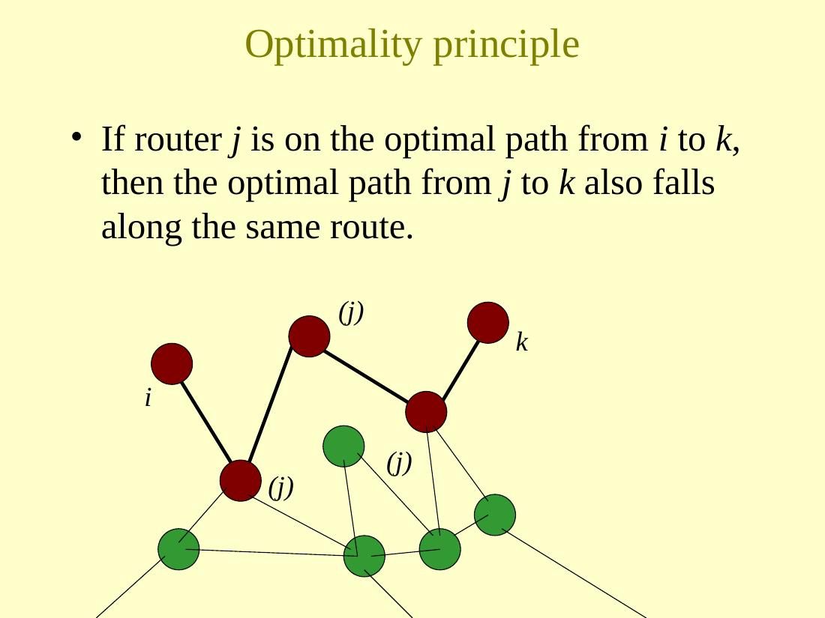
Figure 3.1. The optimality principle: if j is on the optimal path from i to k, then the optimal path from j to k also lies on this route.
Why it matters: This principle gives us a benchmark — a standard we can use to check whether any routing algorithm is producing genuinely optimal paths.

3.7 Sink Trees
Definition: If we collect the optimal routes from every router in the network to one particular destination router, these routes together form a tree shape, with the destination at the root. This is called a sink tree for that destination.
- The distance metric used is often simply the number of hops.
- A sink tree is not always unique — sometimes other trees with the same total path lengths exist.
- The overall goal of all routing algorithms is to discover good sink trees for every router in the network.
TIP
Real-life example: Think of a sink tree like the set of ‘best roads home’ from every neighbourhood in a city — all the roads, drawn together, form a tree shape that funnels every starting point toward one final destination.

KEY POINTS — Chapter 3
Static routing = fixed in advance; Dynamic routing = changes during operation.
Routing metrics (path length, delay, bandwidth, reliability, load, cost) decide what ‘best path’ actually means.
The optimality principle and sink trees are theoretical tools used to judge how good a routing algorithm is.
FREQUENTLY ASKED EXAM QUESTIONS
Q1. Differentiate between adaptive and non-adaptive routing algorithms.
Q2. State and explain the optimality principle.
Q3. What is a sink tree? Is it always unique?
Q4. List any four routing metrics used by routing algorithms.

Chapter 4: Static Routing Algorithms
This chapter covers three classic static (non-adaptive) routing algorithms: Shortest Path Routing (Dijkstra), Flooding, and Flow-based Routing.

4.1 Shortest Path Routing (Dijkstra's Algorithm)
Definition: Shortest Path Routing finds the path with the lowest total cost between a source router and every other router in the network. It was first developed by computer scientist E. W. Dijkstra, so it is often called Dijkstra's algorithm.
Purpose: Given a network topology and a set of weights (costs) describing how expensive it is to send data across each link, find the cheapest path from one specified source to all other destinations.
How it works — Step-by-step process:
- Mark the source node as permanent (its shortest distance, zero, is now fixed and certain).
- Designate the source node as the current working node.
- Set the tentative (temporary, not-yet-final) distance to every other node to infinity.
- While some nodes are still not marked permanent, repeat the next two steps:
  - Compute the tentative distance from the source to every node adjacent to the working node. If this new computed distance is shorter than the node's current tentative distance, replace it, and record the working node as the path's previous step (label).
  - Look at all tentatively labelled nodes in the whole graph. Pick the one with the smallest tentative distance and make it the new working node. Mark this node permanent.
The algorithm keeps repeating this process until every node has been marked permanent. At that point, the shortest path (and its cost) from the source to every other router is known.
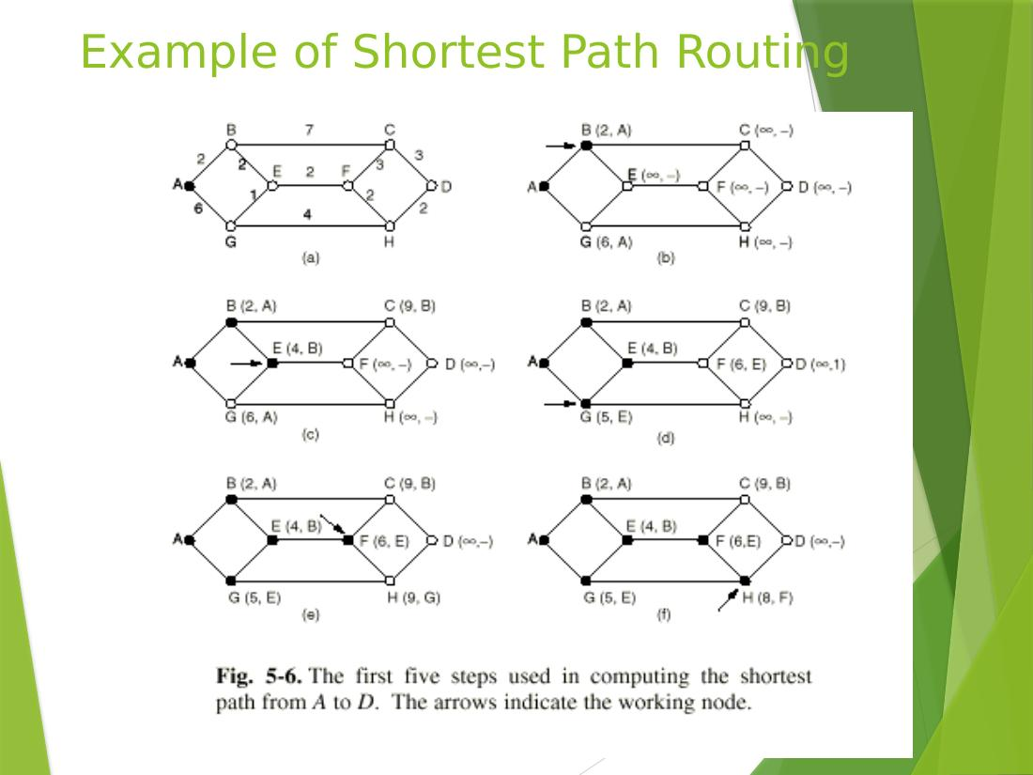
Figure 4.1. Step-by-step example of computing the shortest path from router A to router D. The arrows show the current working node at each step (a–f).
Reading the figure: Each node label, for example C (9, B), means: ‘the tentative distance to C is 9, and the previous router on that path is B.’ As the algorithm proceeds from (a) to (f), more and more nodes become permanent (shown as filled/black dots), and their distances stop changing.

Why the Shortest Path Algorithm Works
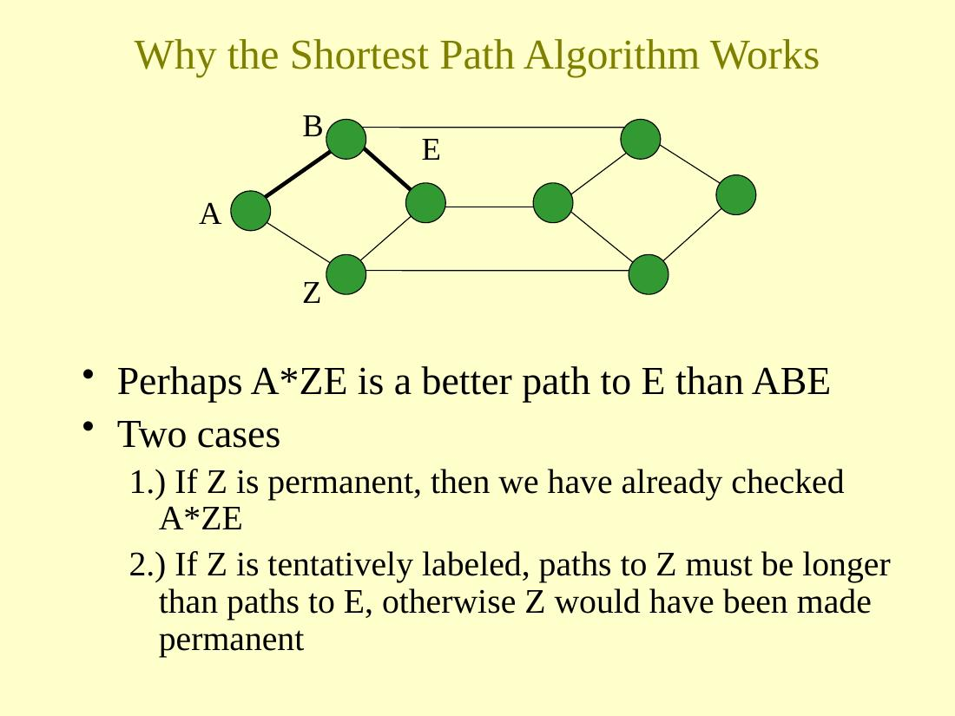
Figure 4.2. Could path A–Z–E be shorter than the already-found path A–B–E? Two cases must be checked.
Suppose we wonder if there is a faster route to E through some other node Z (written A*ZE) than the route already found through B (ABE). There are two possible cases:
- If Z is already permanent, then the algorithm has already checked the path through Z, so nothing is missed.
- If Z is still only tentatively labelled, then the path to Z must already be longer than the path to E — otherwise Z would have become permanent before E did.
In both cases, the algorithm is guaranteed to find the true shortest path.
Property | Details
Type | Static (non-adaptive) routing algorithm
Advantages | Always finds the mathematically shortest (cheapest) path; well understood and reliable.
Disadvantages | Needs full knowledge of network topology and link costs in advance; recalculation is needed if the topology changes.
Applications | Used as the core path-computation step inside Link State Routing (covered in Chapter 5).
TIP
Exam Tip: Be ready to manually trace through a small Dijkstra example, step by step, exactly like Figure 4.1 — this is one of the most common exam questions.

4.2 Flooding
Definition: Flooding is a very simple static routing algorithm in which a router sends every incoming packet out on every outgoing line, except the line the packet arrived on.
Why it is sometimes called ‘brute force routing’: it does not try to be clever about choosing one good path — it simply sends copies everywhere.
- Every incoming packet is duplicated and sent on every outgoing line.
- Flooding always finds the shortest path quickly, since every possible path is tried at once.
- However, it also creates many extra, unnecessary long paths, wasting bandwidth.
- To stop packets from circulating forever, a Time To Live (TTL) counter is set, usually equal to the size (diameter) of the subnet; each router reduces it by one, and the packet is discarded when it reaches zero.

Selective Flooding
Selective flooding is an improved version: instead of flooding on every line, the router only floods packets roughly in the direction of the destination, reducing wasted traffic.
Flooding is impractical for everyday use because it wastes bandwidth, but it is genuinely useful in a few special situations:
- Military applications, where the network must keep working even if many routers are destroyed.
- Distributed databases, where information must reliably reach every node.
- As a metric for comparison: since flooding tries every path, it is sometimes used as a baseline to measure how good other routing algorithms are.
Property | Details
Type | Static (non-adaptive) routing algorithm
Advantages | Extremely simple; very reliable (a copy will get through if any path exists); finds the shortest path.
Disadvantages | Generates huge numbers of duplicate packets; wastes bandwidth; not practical for normal traffic.
Applications | Military networks, distributed databases, used as a comparison baseline.

4.3 Flow-Based Routing
Definition: Flow-based routing chooses static routes by considering not just the network topology, but also the expected traffic matrix (how much traffic flows between each pair of routers) and the capacity matrix (how much capacity each link has).
Why it is needed: A path that looks shortest on a topology diagram may not actually be fastest if that path is heavily loaded. For example, path A-C-F-E-D might be faster than path A-B-D if links A-B and/or B-D are heavily loaded with other traffic.

Analysing Network Flow (Optimising for Mean Delay)
Flow-based routing tries to choose routes that minimise the mean (average) delay across the whole network. The formula used for the mean delay on one link i is:
Ti = 1 / (u·Ci − λi)
- 1/u is the mean packet size in bits.
- Ci is the capacity of link i, in bits per second (bps).
- λi is the mean flow (traffic rate) on link i, in packets per second.
Each possible route is given a weight equal to the percentage of total packet traffic that would travel along it. The overall mean delay of the network is the weighted average of the T values for every route. By recalculating this mean delay for many possible route choices, the algorithm can select the set of routes that gives the lowest overall average delay.
Property | Details
Type | Static (non-adaptive) routing algorithm
Advantages | Produces routes that account for real traffic load, not just topology, so it can avoid congested links.
Disadvantages | Needs advance knowledge of the traffic matrix and capacity matrix, which can be hard to predict accurately; still static, so cannot react to sudden changes.
Applications | Network capacity planning and offline route optimisation.

KEY POINTS — Chapter 4
Dijkstra's algorithm always finds the lowest-cost path, growing the set of ‘permanent’ nodes one at a time.
Flooding sends a packet everywhere — simple and reliable, but wasteful.
Flow-based routing chooses routes by considering traffic load, not just topology, aiming to minimise mean delay.
COMMON MISTAKES
Forgetting to mark the source node permanent at the very start of Dijkstra's algorithm.
Confusing flooding (sends to ALL outgoing lines) with normal routing (sends to ONE chosen outgoing line).
FREQUENTLY ASKED EXAM QUESTIONS
Q1. Explain Dijkstra's shortest path algorithm with a step-by-step example.
Q2. What is flooding? Mention its advantages, disadvantages, and applications.
Q3. How does flow-based routing differ from shortest path routing?
Q4. Write the formula for mean delay used in flow-based routing and explain each term.

Chapter 5: Distance Vector Routing

5.1 What Is Distance Vector Routing?
Definition: Distance Vector Routing is an adaptive (dynamic) routing algorithm in which every router maintains a table listing, for every possible destination in the network, the best known distance to that destination and the outgoing line to use to reach it. This table is called a distance vector.
Historical background: Distance Vector Routing is also known as the Bellman-Ford algorithm (named after its mathematical inventors). It was:
- The original routing algorithm used in the ARPANET — the early network that grew into today's Internet.
- Previously used on the Internet as a protocol called RIP (Routing Information Protocol).
- Used in early versions of DECnet and Novell's IPX networks.
- Still used in AppleTalk and in Cisco routers (in improved forms).

5.2 How Distance Vector Routing Works
The algorithm works through three simple steps that repeat continuously:
- Each router regularly sends its routing table (its distance vector) to all of its neighbouring routers.
- Each router receives distance vectors from all its neighbours.
- Each router updates its own routing table: if a neighbour has found a shorter route to some destination, the router replaces its own route with the neighbour's better one.
Each entry in the routing table contains two pieces of information received from a neighbour:
- The outgoing line to use for that destination (which of the router's own links leads toward the destination).
- An estimate of the time or distance to the destination. This estimate can be expressed as: number of hops (how many routers to cross), time delay (in milliseconds), packet queue length (how congested the line is), or other similar metrics.
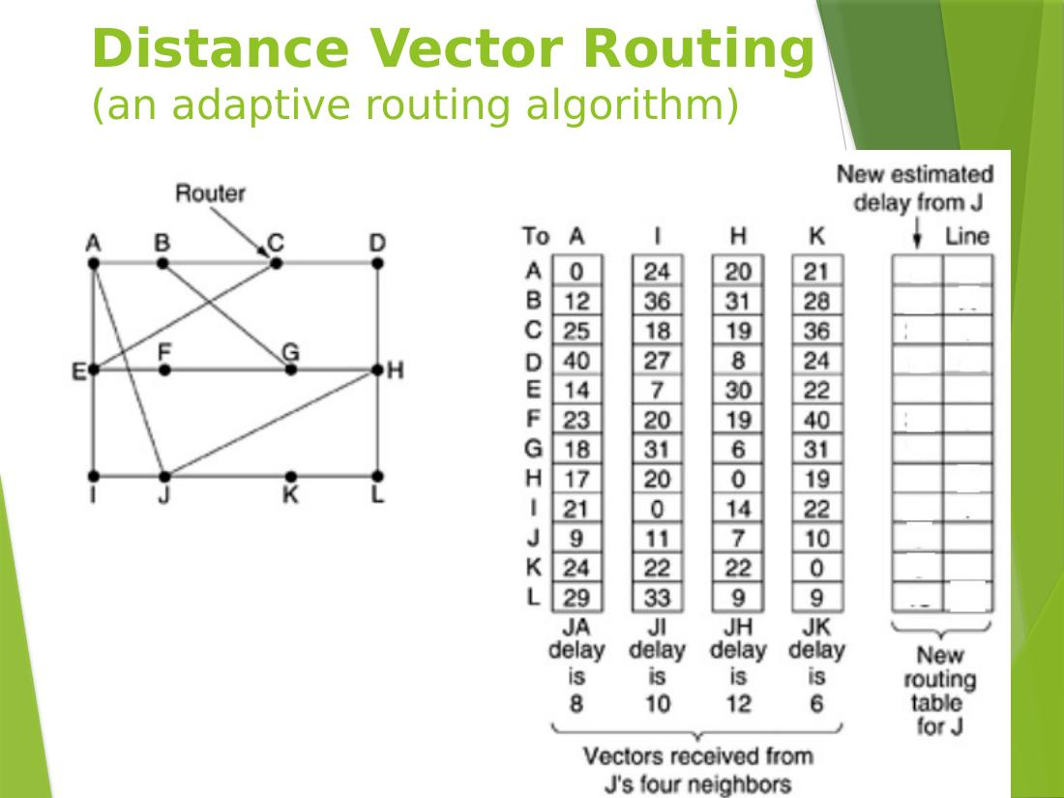
Figure 5.1. Distance Vector Routing: network topology (left) and the routing tables that router J receives from its four neighbours (right). J uses these to compute its new routing table.
Reading the figure: Router J has four neighbours: A, I, H, and K. Each neighbour sends J its own distance table. J then asks: ‘If I send the packet first to neighbour A (at a cost of 8), and A can reach destination B in 12 ms, then my total cost to reach B via A is 8 + 12 = 20 ms.’ J repeats this for all neighbours and picks the lowest cost for each destination.
TIP
Exam Tip: The core formula for Distance Vector is: new distance to destination X via neighbour N = (cost from me to N) + (N's distance to X). Always pick the lowest total across all neighbours.

5.3 The Count-to-Infinity Problem
Distance Vector Routing has a well-known weakness called the Count-to-Infinity Problem. It happens when a link or router fails and routers cannot quickly agree that a destination is now unreachable.
Example scenario:
- Suppose routers A, B, C, D, E are connected in a line: A — B — C — D — E.
- Each router knows that it can reach A in 0, 1, 2, 3, 4 hops respectively.
- Now suppose the link between A and B fails. B can no longer reach A directly.
- But B sees that C claims it can reach A in 2 hops. B thinks: ‘I can reach C in 1 hop, and C says A is 2 hops away, so A must be 3 hops away for me.’ This is wrong — C's route to A actually goes through B itself.
- On the next exchange, C sees that B now claims A is 3 hops away, so C updates to 4 hops. Then B updates to 5 hops, and so on — the count keeps rising toward infinity.
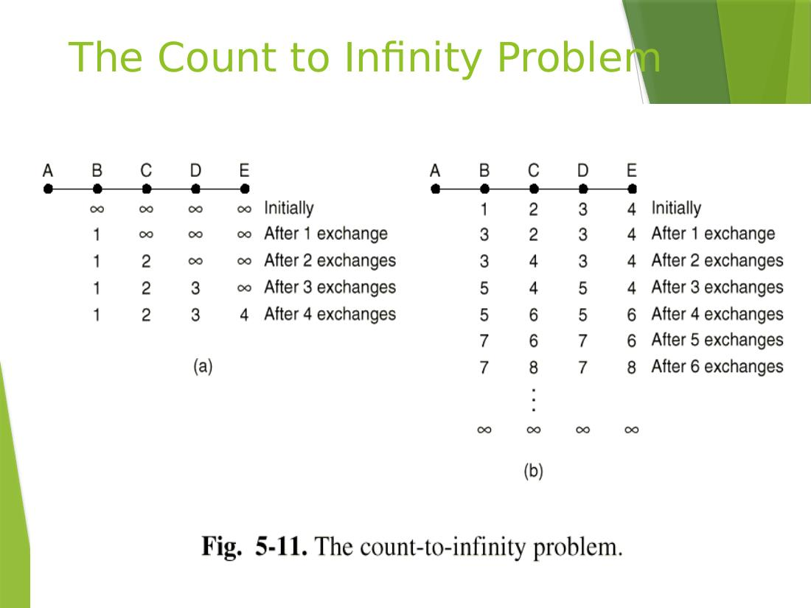
Figure 5.2. Fig. 5-11. The Count-to-Infinity Problem: after a link failure, routers slowly count upward rather than immediately declaring the destination unreachable.
The count continues rising very slowly until it reaches some predefined maximum value (for example, 16 in RIP), at which point the route is declared unreachable. This wastes time and routing table space, and the convergence (agreement on the correct routing tables) is very slow. This is called slow convergence.

5.4 The Split Horizon Solution
Definition: Split Horizon is a technique used to reduce the Count-to-Infinity problem. The rule is simple: a router does not advertise a route back on the same line from which it learned that route.
In other words, if router C learned that it can reach destination A via line B, then C will report an infinite (unreachable) distance to A when it talks to B. C tells the truth to all other neighbours, but ‘lies’ to B, saying A is infinitely far away. This prevents B from mistakenly thinking C has a better route to A.
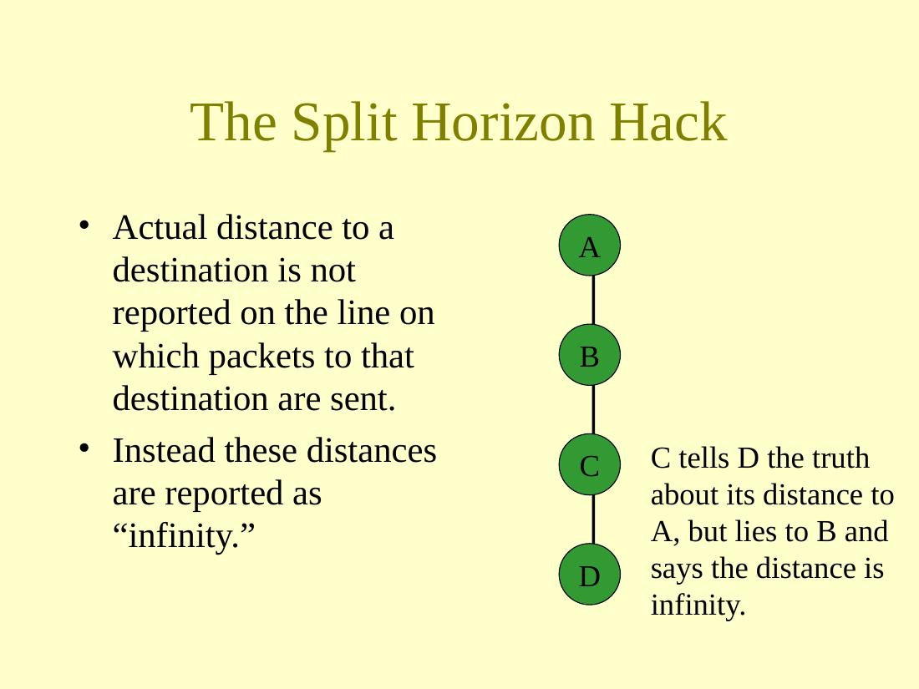
Figure 5.3. Split Horizon: C tells the truth about its distance to A to router D, but reports infinity to router B (since C's route to A passes through B).

5.5 When Split Horizon Fails
Split Horizon solves the problem for simple linear chains, but it fails in networks that have loops (cycles). Consider a topology where routers A, B, C, and D are all interconnected in a loop or ring.
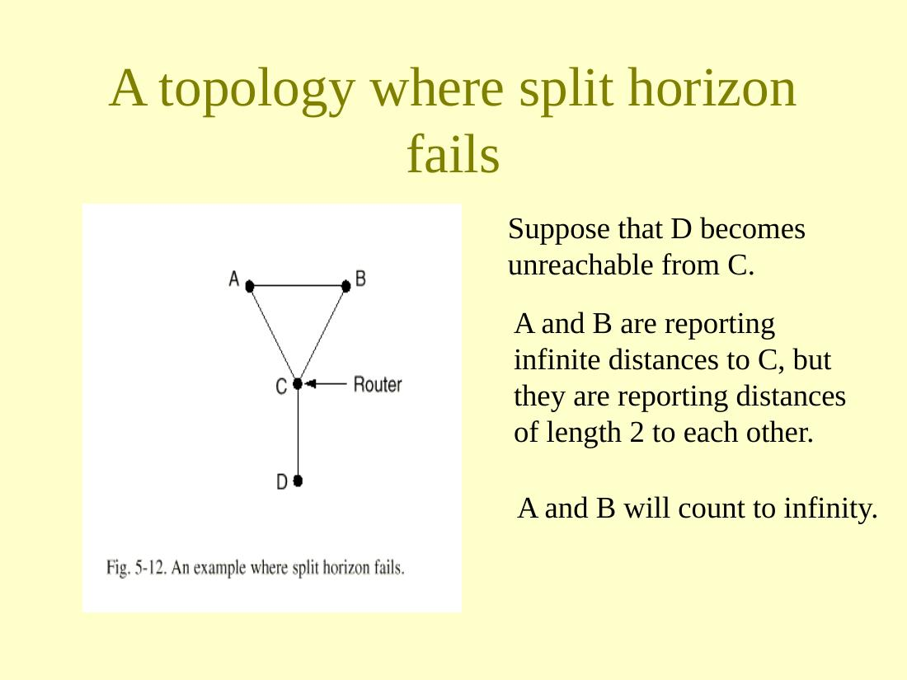
Figure 5.4. A topology where Split Horizon fails: if D becomes unreachable from C, routers A and B will still count to infinity because they report finite distances to each other.
In this looped topology, if destination D becomes unreachable from C: Routers A and B both tell each other that they can still reach D (each through the other), because neither of them directly uses the broken link. Since neither A nor B is the one that ‘told’ the other about D, Split Horizon does not stop them. They will count to infinity together.
TIP
Exam Tip: Split Horizon is a partial fix — it helps with simple linear topologies but fails in networks with loops or cycles.
Property | Details
Type | Adaptive (dynamic) routing algorithm
Information used | Distance vectors received from neighbouring routers
Advantages | Simple to implement; each router only needs to talk to its neighbours, not the whole network.
Disadvantages | Slow convergence after topology changes; suffers from the Count-to-Infinity problem; does not scale well to large networks.
Applications | RIP (Routing Information Protocol), AppleTalk, older Cisco protocols.

KEY POINTS — Chapter 5
Each router shares its full distance vector (table of best-known distances) with its neighbours periodically.
The Count-to-Infinity problem occurs when a path fails and routers slowly count upward instead of quickly detecting the failure.
Split Horizon prevents routers from advertising a route back on the line it was learned from, but does not work in all topologies.
COMMON MISTAKES
Forgetting that Distance Vector is adaptive (dynamic), not static.
Thinking Split Horizon solves Count-to-Infinity completely — it only solves it for simple topologies without loops.
FREQUENTLY ASKED EXAM QUESTIONS
Q1. Explain the Distance Vector Routing algorithm with an example.
Q2. What is the Count-to-Infinity problem? Why does it occur?
Q3. Explain the Split Horizon technique. When does it fail?
Q4. Compare Distance Vector Routing with Link State Routing.

Chapter 6: Link State Routing

6.1 Overview of Link State Routing
Definition: Link State Routing is an adaptive (dynamic) routing algorithm in which every router builds a complete map of the entire network topology and then independently computes the shortest path to every other router using Dijkstra's algorithm.
Why was it needed? Distance Vector Routing suffers from slow convergence and the Count-to-Infinity problem. Link State Routing was designed to converge much faster and to scale to larger networks.
Link State Routing works through five steps. Every router performs all five steps:
- Discover your neighbours and learn their network addresses.
- Measure the cost (delay) to each neighbour.
- Construct a link state packet (LSP) containing all of this information.
- Send this link state packet to all other routers in the network.
- Compute the shortest path to every other router using Dijkstra's algorithm.

6.2 Step 1 — Discovering Neighbours
When a router first starts up, it needs to find out which other routers it is directly connected to. To do this, it sends a special Hello packet out on each of its point-to-point lines.
- The router at the other end of each line receives the Hello packet and replies with its own address.
- After receiving these replies, the first router now knows the identity (address) of each of its direct neighbours.
Real-life example: This is like arriving at a new office and introducing yourself to every person sitting next to you. After the introductions, you know who your immediate neighbours are.

6.3 Step 2 — Measuring Line Cost
Once a router knows who its neighbours are, it measures the cost of the link to each one. Cost is usually measured as delay (the time it takes for a packet to travel across the link).
How to measure: The router sends a special ECHO packet to the neighbour. The neighbour is required to reply to the ECHO packet immediately, without any delay. The router measures the total round-trip time (time to send + time to receive the reply) and uses half of it as the one-way delay.

Should Queue Time Be Included in the Measurement?
This is an important design question. When measuring delay, should the router include the time a packet spends waiting in the queue at the neighbour's router?
Argument in favour of including queue time:
- Including queue waiting time gives a more accurate picture of the real-world delays that packets experience, since a busy router will make the link effectively slower.
Argument against including queue time:
- If queue waiting time is included, the measured delay will vary based on current traffic. This will cause routers to constantly prefer the lightest-loaded path. As traffic shifts to the new ‘best’ path, that path becomes loaded too, and all routers switch away from it again. The network oscillates between paths and never settles down.
- This oscillation problem is illustrated by a ring topology where all nodes are sending to one destination: each node must choose to route clockwise or counter-clockwise, and if cost depends on load, the choice keeps flipping. The network never stabilises.
TIP
Conclusion: Only transmission time (the time to put bits onto the wire) should be measured, not queue waiting time. This avoids the oscillation problem and gives stable, predictable routes.

6.4 Step 3 — Building Link State Packets
After measuring link costs, each router builds a Link State Packet (LSP). An LSP contains:
- The identity (address) of the router that created the packet.
- A list of all of its neighbours, together with the cost (delay) to each one.
- A sequence number — a counter that increases each time a new LSP is created.
- A time-to-live (TTL) value.
When should a router build a new LSP?
- Periodically: every router creates and sends a new LSP at regular intervals (for example, every 30 seconds or every few minutes).
- On significant events: a router also creates and sends a new LSP immediately whenever something important changes — for example, when a link goes down or comes back up, or when the cost of a link changes significantly.

6.5 Step 4 — Distributing Link State Packets
Each LSP needs to reach every other router in the network, so all routers have the same complete picture. This is done using selective flooding.
- Each router forwards a received LSP on all its outgoing lines except the line it arrived on (exactly like flooding, but with extra safeguards).
- Sequence numbers prevent duplicate packets from being re-forwarded. If a router receives an LSP it has already seen (same source, same or lower sequence number), it discards the duplicate.
- LSPs with a lower sequence number than the most recently seen one are rejected as obsolete (out-of-date).
This ensures that every router eventually receives every LSP, and the most recent information always replaces older information.

6.6 Step 5 — Computing New Routes
Once a router has received LSPs from all other routers in the network, it has a complete map of the network — it knows every router and every link cost. The router then runs Dijkstra's Shortest Path algorithm on this map to compute the shortest path from itself to every other router.
The output is the router's new routing table, which it will use for all forwarding decisions until the next round of LSPs causes another update.
Property | Details
Type | Adaptive (dynamic) routing algorithm
Information source | Complete network map built from Link State Packets flooded by all routers
Path computation | Dijkstra's algorithm run independently by each router on its own complete map
Advantages | Converges quickly; no Count-to-Infinity problem; scales well; accurate.
Disadvantages | Requires more memory (must store the whole network map); more processing; more bandwidth for flooding LSPs.
Used in | OSPF (Open Shortest Path First), IS-IS — the main routing protocols of today's Internet.
Comparison | Distance Vector Routing | Link State Routing
Information shared | Own routing table to neighbours only | Full topology info (LSP) to all routers
Network map | Not maintained; inferred indirectly | Each router has a complete map
Path computation | Implicit, through repeated table exchange | Explicit Dijkstra on the full map
Convergence speed | Slow (takes many exchange rounds) | Fast (each router computes independently)
Count-to-Infinity? | Yes | No
Memory/CPU use | Low | Higher
Real-world protocol | RIP | OSPF, IS-IS

KEY POINTS — Chapter 6
Link State Routing uses Hello packets to find neighbours, ECHO packets to measure delay, and selective flooding to share topology maps.
Dijkstra's algorithm is run by each router on its own full copy of the network map.
Only transmission delay (not queue delay) should be measured to avoid path oscillation.
Link State converges faster than Distance Vector and has no Count-to-Infinity problem.
FREQUENTLY ASKED EXAM QUESTIONS
Q1. List the five steps of Link State Routing and explain each one.
Q2. How does a router discover its neighbours in Link State Routing?
Q3. Should queue time be included when measuring link cost? Justify your answer.
Q4. Compare Distance Vector Routing and Link State Routing.

Chapter 7: Hierarchical Routing and Routing for Mobile Hosts

7.1 Hierarchical Routing
Definition: Hierarchical Routing is an approach to routing in very large networks where routers are divided into regions (groups), and a router only needs to know the detailed routes within its own region. For destinations in other regions, it only needs to know which region they belong to and a route to that region.
Why it is needed: As a network grows larger, routing tables grow too. In a network of N routers, a router might need to store N-1 routing table entries. With thousands or millions of routers (like the Internet), this becomes impractical.
How hierarchical routing works:
- Routers are grouped into regions (similar to how a telephone network is grouped into area codes, countries, and continents).
- A router knows the complete, detailed routes to every other router within its own region.
- For destinations outside its own region, the router only stores the route to the gateway router of that distant region, not the individual routes inside it.
- This structure mirrors how telephone routing works: city level, state level, country level, continent level.
How many levels should the hierarchy have? The mathematically optimal number of hierarchical levels for a network of N routers is ln(N) (the natural logarithm of N). This minimises the total routing table size.
TIP
Real-life example: When you address a letter, you write the city, the state, and the country. The postal service does not need every town to know every other town — it just needs each town to know its own region and how to forward to other regions.
Property | Details
Advantage | Greatly reduces routing table size; scales to very large networks.
Disadvantage | Routes may not be globally optimal because a router ignores detailed topology of other regions.
Used in | The Internet's BGP (Border Gateway Protocol) follows hierarchical principles.

7.2 Routing for Mobile Hosts
Traditional routing assumes computers stay in one fixed location. But portable computers (laptops, phones) can move from place to place, connecting to different parts of the network at different times. This creates a challenge: how do you route packets to a computer whose location keeps changing?
The proposed solution uses a concept of home agents and foreign agents:

Key Concepts
- Home location: Every mobile device has a permanent ‘home’ network — where it is registered and where packets are normally sent.
- Home agent: A process (software) running at the mobile device's home network that keeps track of where the device currently is.
- Foreign agent: When a mobile device moves to a remote (foreign) network, it contacts a local process called the foreign agent at that network.

How the Process Works
- The foreign agent periodically broadcasts its presence on the local network.
- The mobile device, when it arrives at the new network, registers itself with the foreign agent, giving its permanent home address.
- The foreign agent contacts the home agent and reports the mobile device's new location (the address at the foreign network).
- Security checks are used to verify the identity of the mobile device (so that someone else cannot pretend to be it).
- The home agent registers the mobile device under its new foreign address.
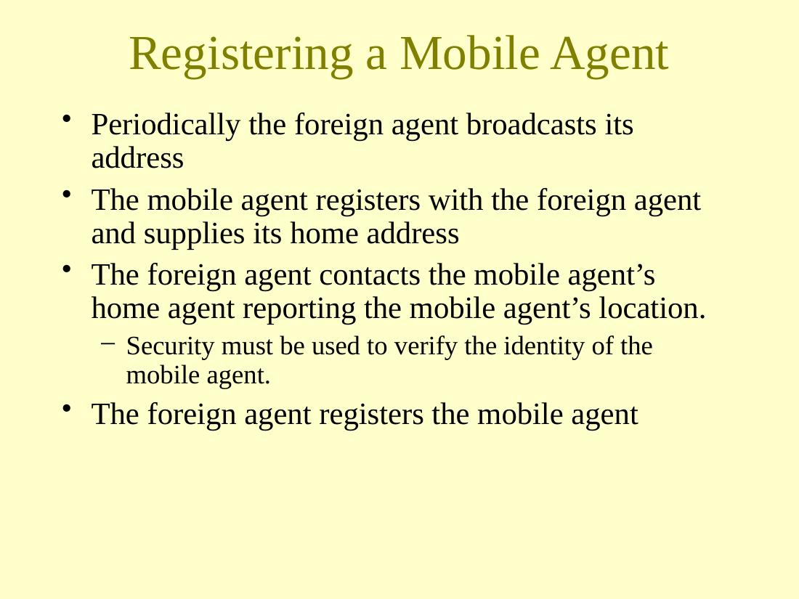
Figure 7.1. Mobile routing: the home agent, foreign agent, and mobile device working together to route packets to a user who has moved to a remote network.

How Packets Are Routed to the Mobile Device
- When another computer sends a packet to the mobile device's permanent address, the packet is routed to the mobile device's home network, where the home agent receives it.
- The home agent then re-routes (tunnels) the packet to the foreign agent at the mobile device's current location.
- Optionally, the home agent also informs the original sender of the mobile device's temporary remote address, so that future packets can be sent directly, without going through the home network every time.
KEY POINTS — Chapter 7
Hierarchical routing reduces table size by grouping routers into regions; the optimal number of levels is ln(N).
Mobile routing uses home agents (at the permanent home network) and foreign agents (at the current location) to track and deliver packets to moving devices.
Security is essential in mobile routing to prevent impersonation of mobile devices.

Chapter 8: Broadcast and Multicast Routing

8.1 What Is Broadcasting?
Definition: Broadcasting means sending a packet to every node (computer or router) in the entire network, not just to one specific destination.
There are several methods to implement broadcasting. Each has different efficiency levels:

8.2 Methods for Broadcast Routing

Method 1 — Separate Packets
The source router sends a separate, individual copy of the packet to every single destination in the network. This is the simplest method but also the most wasteful: the source must send N-1 packets if there are N nodes.

Method 2 — Flooding
Use the flooding technique (covered in Chapter 4). Every router that receives the broadcast packet forwards it on all outgoing lines except the one it arrived on. Flooding reaches everyone, but creates many duplicate copies.

Method 3 — Multidestination Routing
Each broadcast packet carries a list of intended destinations. When a router receives the packet, it duplicates it only for the outgoing lines that lead toward at least one destination in the list. This wastes less bandwidth than flooding, but the packet headers can get very large if there are many destinations.

Method 4 — Spanning Tree Routing
Definition: A spanning tree is a tree-shaped subset of the full network that includes every router in the network but contains no loops (no cycles). Packets are only forwarded along the edges of the spanning tree.
Why is the spanning tree useful?
- A spanning tree uses the minimum number of packets necessary to reach every router.
- Every router appears exactly once in the tree, so there are no duplicate deliveries.
Limitation: Routers must know the spanning tree in advance. Spanning tree knowledge is readily available with Link State Routing (because every router has a full map), but it is not available with Distance Vector Routing.
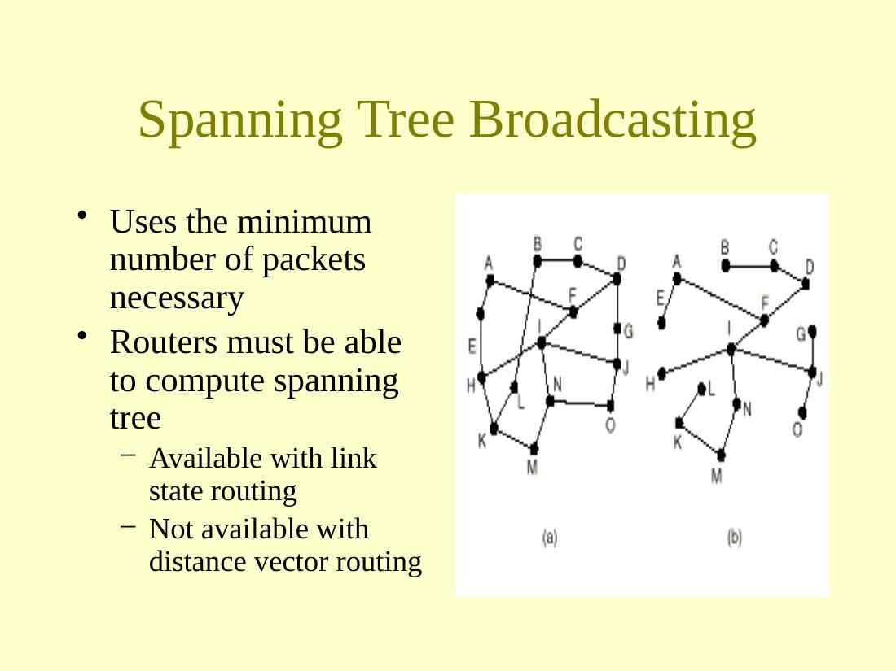
Figure 8.1. Spanning tree broadcasting: only the edges of the spanning tree are used, ensuring each router receives exactly one copy of the broadcast packet.

8.3 Reverse Path Forwarding (RPF)
Definition: Reverse Path Forwarding is a practical broadcast method used when the full spanning tree is not available (for example, when Distance Vector Routing is being used). It provides an approximation of spanning tree routing.
How RPF works:
- When a router receives a broadcast packet from source S, it checks: is this packet arriving on the same outgoing line that I normally use to send packets TO source S?
- If yes: the packet has arrived on the best path from S, so the router duplicates it and forwards it on all other outgoing lines.
- If no: the packet is a duplicate that has arrived by a longer route, so the router simply discards it.
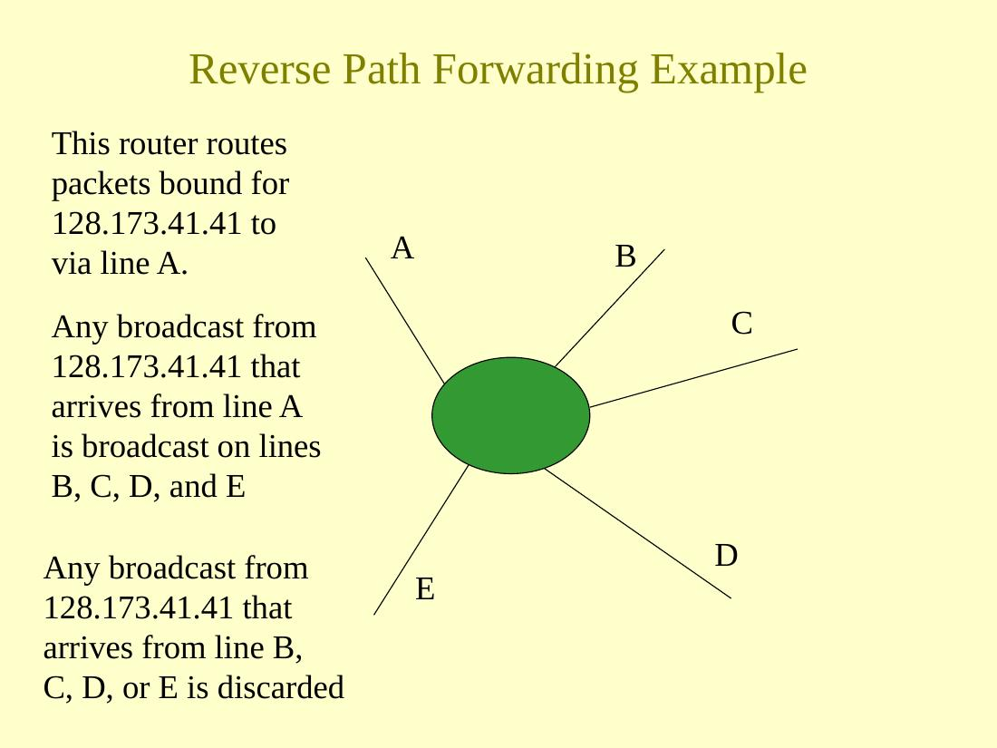
Figure 8.2. Reverse Path Forwarding example: a router checks if the broadcast packet from 128.173.41.41 arrives via line A (its normal route to that source). If so, it forwards to B, C, D, E. If it arrives via B, C, D, or E, it is discarded.
RPF is efficient because it avoids creating too many duplicates without needing a precomputed spanning tree.
TIP
Exam Tip: The key test in RPF — does the packet arrive on the SAME line I would normally use to SEND to the source? Yes = forward; No = discard.

8.4 Multicast Routing
Definition: Multicast routing is a method for sending packets to a well-defined group of destinations, rather than broadcasting to everyone. The group is called a multicast group.
How multicast routing works:
- Hosts join multicast groups. They inform their local routers that they want to receive traffic for a particular group.
- Routers exchange group membership information throughout the network.
- Each router computes a separate spanning tree for each multicast group. The spanning tree for a group includes only the routers needed to deliver packets to the members of that group.
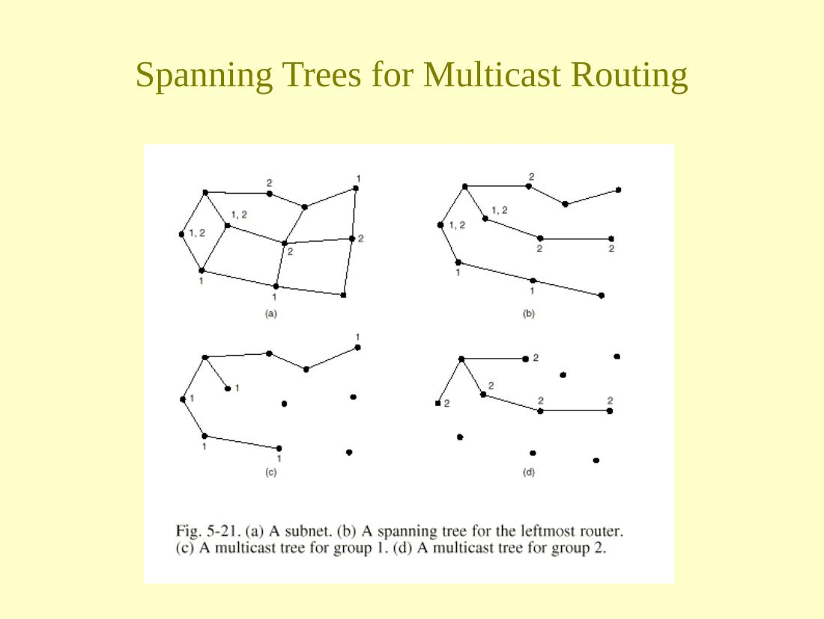
Figure 8.3. Spanning trees computed for two different multicast groups. Each tree includes only the routers needed to reach the members of that particular group.
How the spanning tree is computed depends on which routing protocol is being used:
- With Link State Routing: routers already know the complete topology, so they can directly compute the spanning tree for each multicast group.
- With Distance Vector Routing: Reverse Path Forwarding is used as an approximation.
Pruning: In Distance Vector environments, when a router receives a multicast packet for a group but has no members of that group (no subscribers), it sends a PRUNE message back to the source router. This tells the source not to send future multicast packets down that branch, so unnecessary traffic is avoided.
Method | Needs Spanning Tree? | Efficiency | Works With
Separate Packets | No | Low (N-1 packets sent) | Any routing
Flooding | No | Low (many duplicates) | Any routing
Multidestination | No | Medium | Any routing
Spanning Tree | Yes | Highest (minimum packets) | Link State Routing
Reverse Path Forwarding | No | Good approximation | Distance Vector or Link State
KEY POINTS — Chapter 8
Spanning Tree broadcasting uses the minimum number of packets but requires prior knowledge of the tree.
RPF is a practical approximation of spanning tree broadcasting when the full tree is not known.
Multicast routing sends to a defined group, not everyone; each group has its own spanning tree.
PRUNE messages allow routers to stop receiving multicast traffic for groups they do not serve.
FREQUENTLY ASKED EXAM QUESTIONS
Q1. What is a spanning tree? Why is it preferred for broadcasting?
Q2. Explain the Reverse Path Forwarding technique for broadcasting.
Q3. How does multicast routing differ from broadcast routing?
Q4. What is a PRUNE message in multicast routing?

Chapter 9: Congestion Control Algorithms

9.1 What Is Congestion?
Definition: Congestion is the situation in which too many packets are present in the network (or in part of the network) at the same time, causing performance to degrade significantly.
Real-life example: Congestion in a network is exactly like a traffic jam on a motorway. Too many cars (packets) are trying to use the same road (link) at the same time. Even though the road has not changed, everything slows down dramatically.

9.2 Causes of Congestion
Congestion occurs when a router receives data faster than it can send it onward. The main causes are:
- Insufficient bandwidth: the outgoing link simply does not have enough capacity to carry all arriving traffic.
- Slow hosts: if the destination computer receives packets more slowly than they arrive, the router must buffer (hold) them.
- Multiple simultaneous arrivals: data arriving on many different incoming lines is all destined for the same single outgoing line, creating a bottleneck.
- An unbalanced system: fixing congestion at one router often just moves the bottleneck to the next router downstream.

9.3 Why Congestion Makes Itself Worse
A major problem with congestion is that it feeds itself, creating a vicious cycle:
- Incoming messages must be placed in queues inside the router while waiting for their outgoing line.
- Queues have a finite size. When a queue fills up, the router must discard (drop) new arriving packets.
- Dropped packets trigger retransmissions: the sender, not having received an acknowledgement, sends the packet again — adding even more traffic to the already congested network.
- Long queue delays also cause timeouts: the sender thinks the packet was lost even though it is still in the queue, and sends a duplicate — again adding more traffic.
- Senders trying to reach congested destinations themselves become congested: they must keep retransmitting unacknowledged packets and keep those packets in memory until they are acknowledged.
TIP
Key insight: The more congested a network becomes, the more retransmissions are triggered, which makes it even more congested. This is why congestion control must prevent congestion from starting, not just react after it begins.

9.4 Congestion Control vs Flow Control
These two concepts are often confused but are quite different:
Aspect | Flow Control | Congestion Control
Scope | Point-to-point between one sender and one receiver | The entire network or subnet
Problem it solves | A fast sender overwhelming a slow receiver | Too many packets in the network causing global slowdown
Example | A fast server sending data faster than a slow laptop can process it | Many users all downloading at the same time, clogging routers

9.5 Two Categories of Congestion Control

Open Loop Solutions (Preventive)
Definition: Open loop solutions try to prevent congestion from occurring in the first place. They do not use runtime feedback from the network.
- Decisions are made based on static policies set up in advance.
- Examples: admission control (refusing new connections when the network is already busy), traffic shaping (controlling how fast traffic is injected into the network).

Closed Loop Solutions (Reactive)
Definition: Closed loop solutions use feedback from the network during operation to detect when congestion is occurring and to take corrective action in real time.
The three general principles of closed loop congestion control are:
- Monitor the system to detect when and where congestion is occurring.
- Pass this information to the places (routers or sources) that can take action.
- Adjust the system's operation to correct the problem.
Metrics used to detect congestion in closed loop systems:
- Percentage of packets discarded because router buffers (queues) are full.
- Average queue length at a router.
- Percentage of packets that time out and must be retransmitted.
- Average packet delay.
- Standard deviation of packet delay (high variation means unstable service).
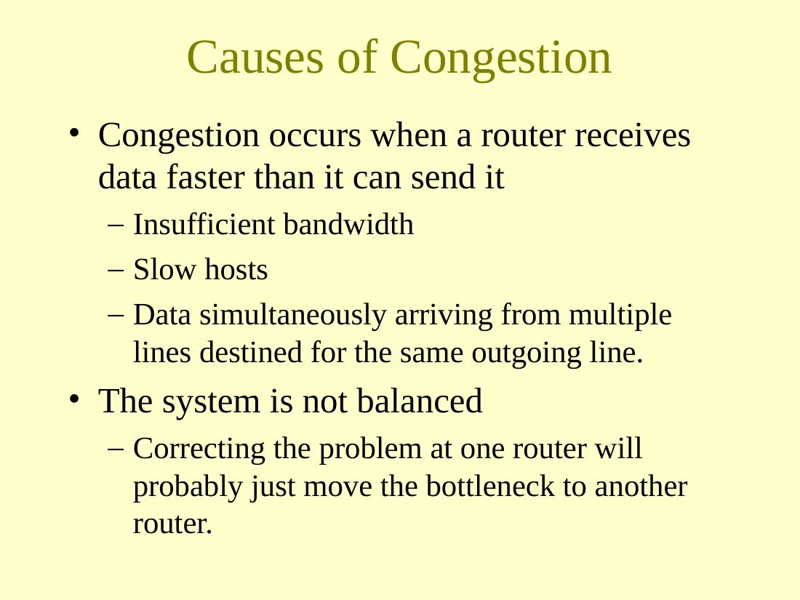
Figure 9.4. Causes of congestion and the escalating cycle of dropped packets, retransmissions, and further congestion.

9.6 Methods for Reducing Congestion
Once congestion is detected, a network can respond in two broad ways:

Increase Resources
- Obtain additional bandwidth by upgrading to faster lines.
- Obtain additional (parallel) links.
- Utilise alternate pathways that are currently less loaded.
- Utilise spare routers that are not currently carrying much traffic.

Decrease Traffic
- Send explicit messages to senders, asking them to slow down (explicit congestion notification).
- Deny service to some users — refuse to accept new connections or packets until the congestion clears.
- Degrade service to some or all users — provide a lower quality of service (lower bandwidth or higher delay) but keep everyone connected.
- Schedule usage: spread traffic across different time periods to achieve a better load balance.
Category | Type | How It Works
Open Loop | Prevention | Admission control, traffic shaping — prevents congestion before it starts
Closed Loop | Detection + Reaction | Monitor metrics, detect congestion, then slow senders or reroute traffic
Increase Resources | Reactive relief | Add bandwidth, use spare routers, use alternate paths
Decrease Traffic | Reactive relief | Slow senders, deny/degrade service, better scheduling
KEY POINTS — Chapter 9
Congestion = too many packets in the network at once. It worsens itself through retransmissions.
Flow control = between sender and receiver; Congestion control = across the whole network.
Open loop prevention stops congestion before it starts; closed loop reacts to congestion using measured feedback.
Reducing congestion = either increase resources (more bandwidth) or decrease traffic (slow senders, deny service).
COMMON MISTAKES
Confusing flow control (sender-to-receiver) with congestion control (network-wide).
Thinking congestion can be fully solved just by adding more bandwidth — the vicious cycle of retransmissions means congestion must be controlled, not just expanded away.
FREQUENTLY ASKED EXAM QUESTIONS
Q1. What is congestion? List the main causes of congestion.
Q2. Distinguish between flow control and congestion control.
Q3. Differentiate between open loop and closed loop congestion control.
Q4. What metrics are used in closed loop congestion control systems?
Q5. What are the two broad approaches to reducing congestion once it is detected?

Chapter 10: Internetworking

10.1 What Is Internetworking?
Definition: Internetworking means connecting multiple, separate networks together so that they function as one larger network. The resulting super-network is called an internet (lowercase i, meaning any collection of connected networks) or, most famously, the Internet (capital I, the global public network).
Why it is needed: No single network can connect every computer in the world. Different organisations and regions build their own networks using different technologies. Internetworking solves the challenge of making all these different networks communicate with each other.
Purpose: The goal is to allow users on any connected network to: (1) communicate with users on all other networks, and (2) access data stored on any other network — regardless of which underlying network technology each part uses.

10.2 How Networks Differ From Each Other
When connecting different networks, the challenge is that they can differ in many ways:
Item | Examples of different values / connections
Services offered | Connection-oriented vs connectionless
Protocols | IP, IPX, SNA, ATM, MPLS, AppleTalk, etc.
Multicasting | May be supported or not supported
Error handling | Various approaches to error detection and correction
Addressing | Different address sizes, formats, and assignments
Broadcasting | Possible vs not possible, different scope
Packet size | Different maximum sizes on different networks
Ordering | Packets may arrive in order or out of order
QoS | Different Quality of Service guarantees
Reliability | Reliable, ordered delivery vs best-effort delivery
Parameters | Different timeouts, flow specifications, etc.
Accounting | By connect time, packet, byte, or not at all

10.3 How Networks Can Be Connected
Several types of devices are used to connect networks. They operate at different layers of the network model:

Repeaters and Hubs (Physical Layer)
Repeaters and hubs operate at the physical layer (Layer 1). They simply take an incoming electrical signal, amplify or regenerate it, and send it out. They do not understand addresses at all. They are used to extend the reach of a single network segment, not to connect different networks.
- Repeaters connect the same type of network (for example, extending a single Ethernet segment).
- Hubs join multiple cables in a star topology but still act as one single collision domain.

Bridges and Switches (Data Link Layer)
Bridges and switches operate at the data link layer (Layer 2). They understand MAC addresses (the hardware addresses on network interface cards).
- A bridge connects two network segments and forwards frames between them based on MAC addresses.
- A switch is essentially a multi-port bridge — it connects many devices and intelligently forwards each frame only to the port where the destination device is connected.
- Bridges and switches can also perform minor protocol translations — for example, bridging between Ethernet and FDDI, or between Ethernet and 802.11 (Wi-Fi).

Routers (Network Layer)
Routers operate at the network layer (Layer 3). They understand IP addresses (logical addresses, not hardware addresses). Routers read the destination IP address of each incoming packet and decide which path to forward it on.
- A router can connect networks that use different technologies and different lower-level protocols.
- A multiprotocol router can handle multiple different network-layer protocols at the same time.
Switch vs Router: a switch only examines the MAC address (hardware, Layer 2 address); a router examines the IP address (logical, Layer 3 address). This is an important distinction.
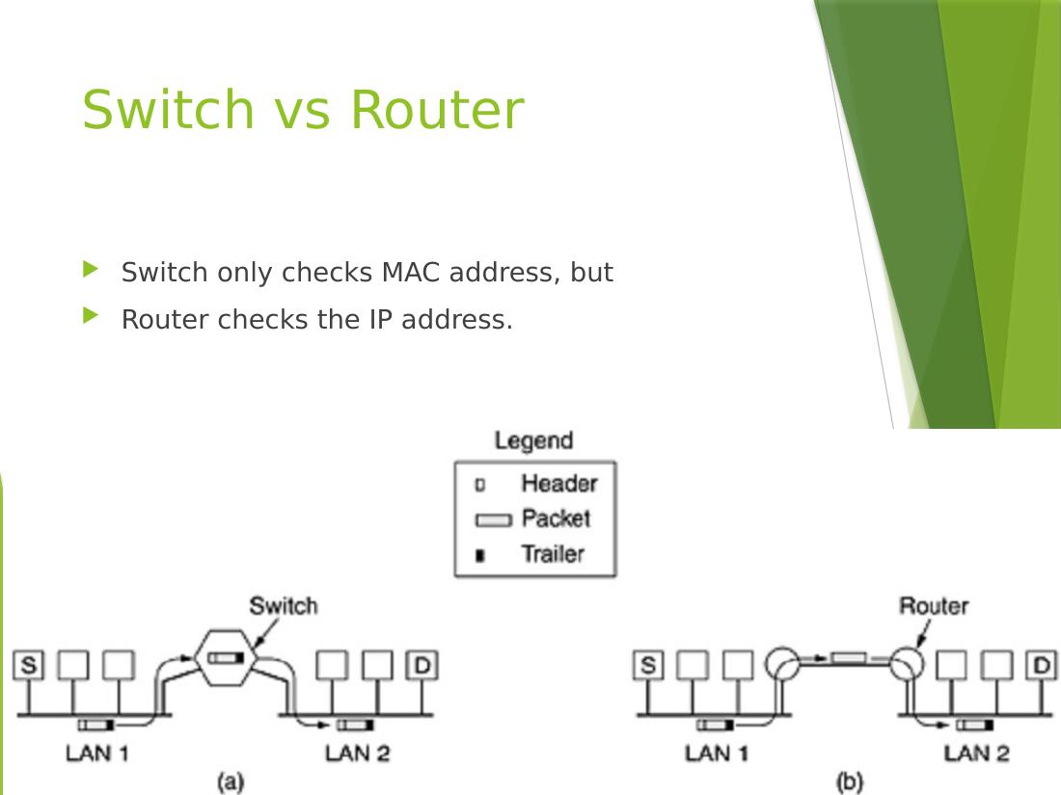
Figure 10.1. Switch vs Router: a switch operates at Layer 2 using MAC addresses; a router operates at Layer 3 using IP addresses.
Device | OSI Layer | Address Used | Connects | Understands Topology?
Repeater / Hub | Layer 1 (Physical) | None | Same type of segment | No
Bridge / Switch | Layer 2 (Data Link) | MAC address | Two or more segments (same or different) | Partially (learns MAC → port mappings)
Router | Layer 3 (Network) | IP address | Different networks | Yes (uses routing tables)
KEY POINTS — Chapter 10
Internetworking = connecting different networks. Networks can differ in services, protocols, packet sizes, addresses, and more.
Repeaters/hubs (Layer 1) cannot connect different networks; bridges/switches (Layer 2) can do minor bridging; routers (Layer 3) are the true internetworking devices.
Switches use MAC addresses; routers use IP addresses — this is a key exam distinction.
FREQUENTLY ASKED EXAM QUESTIONS
Q1. What is a multiprotocol router?
Q2. Compare repeaters, bridges, switches, and routers in a table.
Q3. At which layer does a switch operate? What address does it use?
Q4. Why do networks differ from each other, and what problems does this cause for internetworking?

Chapter 11: Tunneling and IP Fragmentation

11.1 Tunneling
Definition: Tunneling is a technique used when a packet needs to travel through a network that uses a different protocol than the packet itself was designed for. Instead of translating the packet, the original packet is placed inside (encapsulated into) a new outer packet that the intermediate network can understand.
How it works: The source router (on the entry side of the incompatible network) wraps the original packet inside a new packet. This outer packet travels through the intermediate network normally. When it reaches the exit router (on the other side), the outer packet is removed and the original packet is delivered to its destination.
Real-life example: Tunneling is like putting a French letter into a Belgian envelope so it can travel through the Belgian postal system. The Belgian post handles it as a normal Belgian letter. When it arrives at the French destination, the Belgian envelope is opened and the French letter inside is read.
TIP
Exam Tip: Tunneling is the solution when two networks that use the same protocol need to communicate through an intermediate network that uses a different protocol.

11.2 IP Fragmentation — Why It Is Needed
Definition: Fragmentation is the process of breaking a large packet into several smaller pieces (called fragments) so it can pass through a network that cannot carry packets as large as the original.
Reasons why fragmentation is necessary:
- Hardware constraints: for example, an Ethernet frame can hold at most 1500 bytes of data.
- Operating system constraints: for example, an OS may use fixed-size buffers of 512 bytes each.
- Protocol constraints: the packet length field in a protocol header may only have enough bits to represent a limited size.
- Compliance with standards: some networks must comply with national or international size standards.
- Reducing error-induced retransmissions: smaller packets mean that fewer bytes need to be re-sent if an error corrupts a single packet.
- Preventing channel monopolisation: a single large packet should not occupy the entire channel for a long time, blocking all other traffic.

11.3 Maximum Transmission Unit (MTU)
Definition: The Maximum Transmission Unit (MTU) is the largest IP datagram (packet) that a particular network can carry within its own frame format. Each network technology has its own MTU. For example, Ethernet has an MTU of 1500 bytes.
The problem: When a packet is routed across multiple different networks, the routers do not know in advance what the MTU of every downstream network will be. A packet that is 4000 bytes may fit on one network but not on another.
The IP solution: When a packet reaches a router whose outgoing link has a smaller MTU than the packet size, the router fragments the packet into smaller pieces. Each fragment is forwarded independently. If a fragment encounters yet another network with an even smaller MTU, it can be fragmented again.
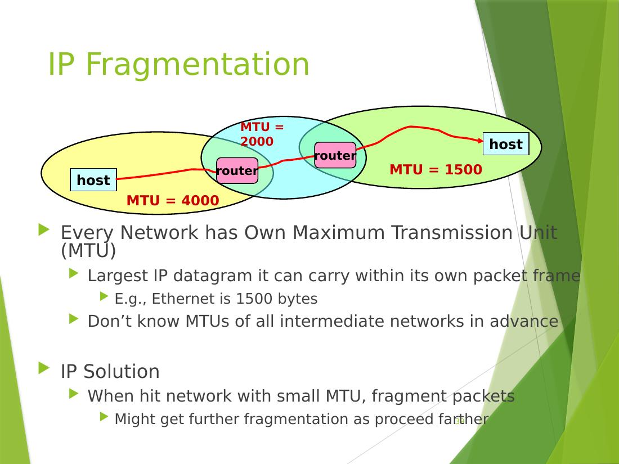
Figure 11.2. IP Fragmentation overview: a packet of 4000 bytes must be fragmented as it travels through networks with different MTUs (4000, 2000, 1500 bytes).

11.4 Fragmentation-Related Fields in the IP Header
The IP header contains four fields that are used specifically to manage fragmentation and later reassembly:
Field | Purpose | Details
Length | Size of this fragment | The total length (in bytes) of this IP fragment, including the IP header.
Identification | Groups fragments together | A unique number assigned by the sender to the original datagram. All fragments of the same datagram share the same Identification number.
Fragment Offset | Position in the original datagram | Indicates where in the original datagram this fragment belongs (measured in units of 8 bytes).
Flags — More Fragments (MF) | Is this the last fragment? | If MF = 1, more fragments follow. If MF = 0, this is the last (or only) fragment.
Flags — Don’t Fragment (DF) | Forbid fragmentation | If DF = 1, the router must NOT fragment this packet. If it cannot forward it without fragmenting, it must drop it and send an error message.

11.5 IP Fragmentation — Worked Examples

Example 1: No Fragmentation Needed (MTU = 4000)
A host sends an IP datagram of total length 3820 bytes (including a 20-byte IP header, so 3800 bytes of data). The first router has an outgoing MTU of 4000 bytes. Since 3820 < 4000, no fragmentation is needed. The packet is forwarded as a single fragment with: Length = 3820, More Fragments (M) = 0 (this is the only and last fragment), Offset = 0.
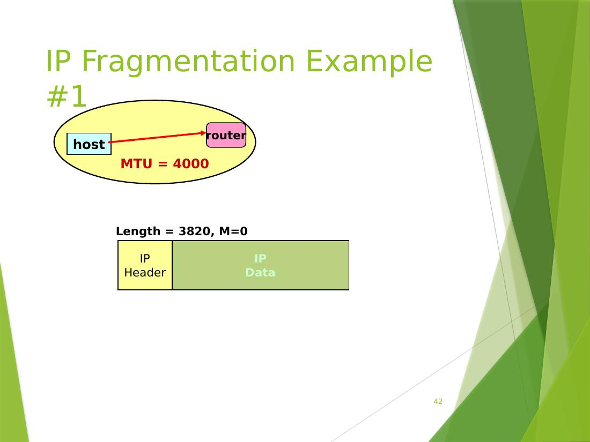
Figure 11.3. Fragmentation Example 1: no fragmentation is needed when the packet (3820 bytes) fits within the outgoing MTU (4000 bytes).

Example 2: Fragmentation into Two Pieces (MTU = 2000)
The same 3820-byte datagram now reaches a router whose outgoing link has an MTU of 2000 bytes. Since 3820 > 2000, the router must fragment.
- IP header size = 20 bytes. So the maximum data per fragment = 2000 - 20 = 1980 bytes.
- Fragment 1: contains the first 1980 bytes of data. Length = 1980 + 20 = 2000, MF = 1 (more fragments follow), Offset = 0 (starts at position 0).
- Fragment 2: contains the remaining 1820 bytes of data. Length = 1820 + 20 = 1840, MF = 0 (this is the last fragment), Offset = 1980 (starts at byte position 1980 of the original data).
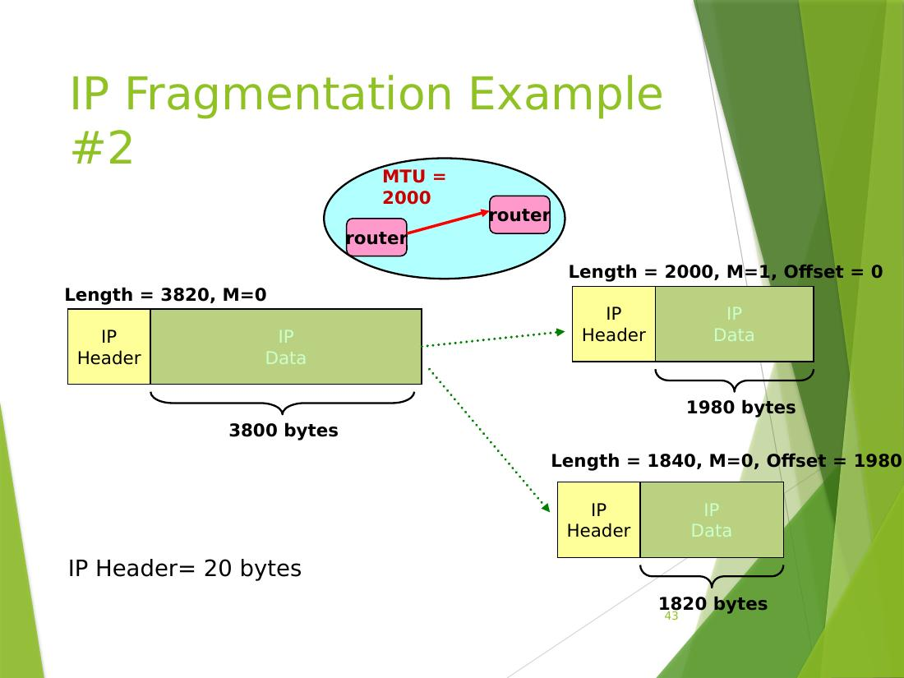
Figure 11.4. Fragmentation Example 2: a 3820-byte datagram is fragmented into two pieces when it encounters a network with MTU = 2000 bytes.

Example 3: Further Fragmentation (MTU = 1500)
Fragment 1 from Example 2 (2000 bytes, MF=1, Offset=0) now reaches another router with MTU = 1500. It must be fragmented again.
- Maximum data per fragment = 1500 - 20 = 1480 bytes.
- New Fragment 1a: first 1480 bytes of the 1980-byte data. Length = 1500, MF = 1, Offset = 0.
- New Fragment 1b: remaining 500 bytes. Length = 520, MF = 1 (because the original datagram still has Fragment 2 to come), Offset = 1480.
- Fragment 2 from Example 2 (1840 bytes, MF=0, Offset=1980) also passes through this router and is fragmented:
  - New Fragment 2a: first 1480 bytes. Length = 1500, MF = 1, Offset = 1980.
  - New Fragment 2b: remaining 340 bytes. Length = 360, MF = 0 (last fragment of entire datagram), Offset = 3460.
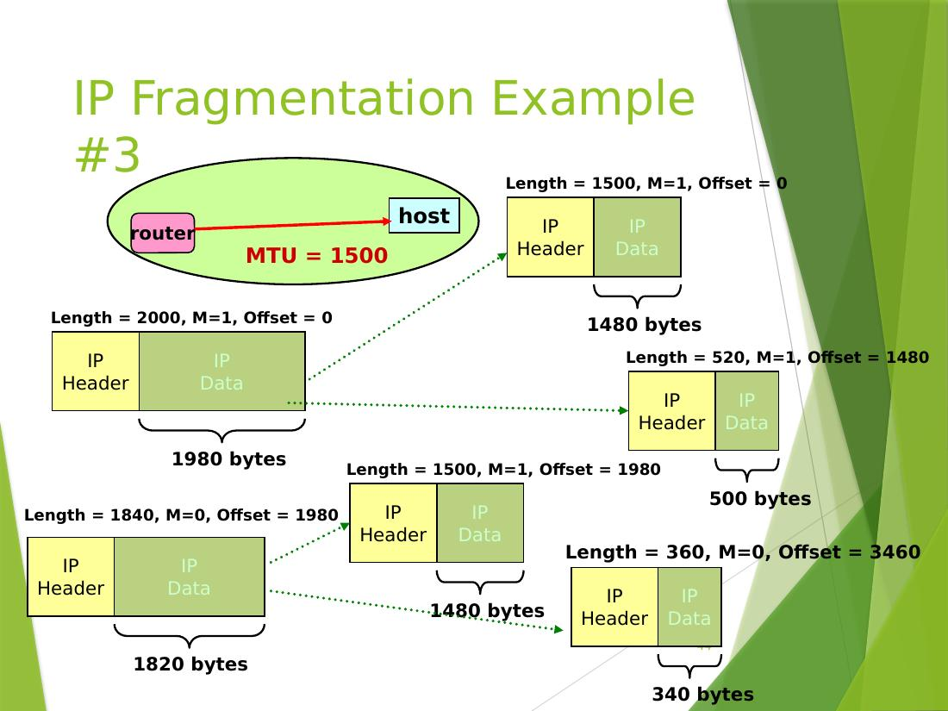
Figure 11.5. Fragmentation Example 3: fragments are fragmented again when encountering an even smaller MTU of 1500 bytes, producing four final fragments.

11.6 IP Reassembly
The original datagram is reconstructed (reassembled) only at the final destination host, never at intermediate routers. This is deliberate: if a router reassembled every datagram, the process would consume enormous amounts of memory and processing time.
Reassembly challenges:
- Fragments may arrive out of order, because different fragments may have taken different paths through the network.
- The receiver does not know how much memory to allocate until the last fragment arrives (since only the last fragment has MF = 0, revealing the total size).
- Some fragments may never arrive — they could be lost or dropped along the way.
- After waiting for a reasonable time, the destination gives up and discards all fragments of the incomplete datagram. An error message may be sent back to the sender.
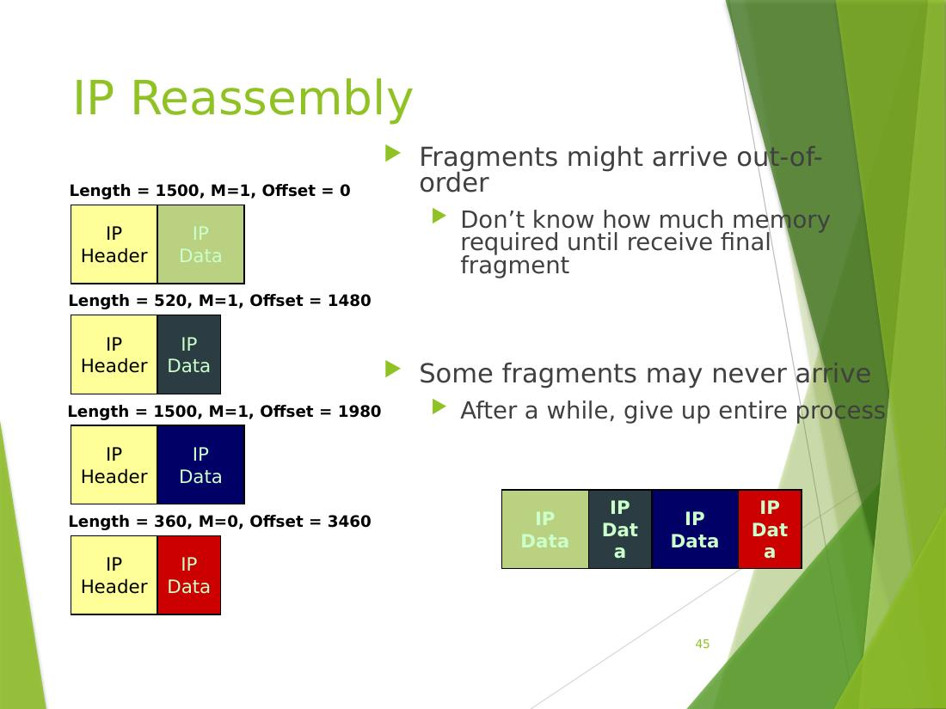
Figure 11.6. IP Reassembly: fragments arrive at the destination with different lengths and offsets; the receiver uses the Identification, Offset, and MF flag to reassemble the original datagram.
TIP
Exam Tip: Remember — fragmentation happens at routers; reassembly happens only at the destination host. Fragments are identified by the same Identification number, sorted by Fragment Offset, and the last one is marked MF=0.
KEY POINTS — Chapter 11
Tunneling encapsulates a packet inside another packet to send it through an incompatible intermediate network.
Fragmentation splits large packets into smaller fragments when the outgoing MTU is too small.
IP header fields for fragmentation: Length, Identification, Fragment Offset, More Fragments flag, Don't Fragment flag.
Reassembly happens only at the destination host, never at intermediate routers.
COMMON MISTAKES
Forgetting that the Fragment Offset field is measured in units of 8 bytes, not individual bytes.
Confusing MF=0 with the first fragment — it is the LAST (or only) fragment that has MF=0.
Assuming reassembly happens at routers — it does NOT; it only happens at the final destination.
FREQUENTLY ASKED EXAM QUESTIONS
Q1. What is tunneling? Give a real-life analogy.
Q2. Why is IP fragmentation necessary? List the reasons.
Q3. Explain the four fragmentation-related fields in the IP header.
Q4. A datagram of 3820 bytes enters a network with MTU = 2000 bytes. Calculate the size, offset, and MF flag of each fragment.
Q5. Why is IP reassembly performed at the destination and not at intermediate routers?

Chapter 12: Complete Summary, Revision Sheet, and Exam Reference

12.1 One-Page Quick Revision Sheet
Use this section for last-minute review before an exam. Each item is a key fact in one sentence.
- Fast Ethernet = 100 Mbps; uses CSMA/CD; main standards: 100BaseTX (copper, 100 m), 100BaseFX (fibre, up to 20 km).
- Gigabit Ethernet = 1 Gbps; backward compatible; 1000BaseLH reaches 80 km on singlemode fibre.
- Routing algorithm = decides the path; forwarding = sends the packet along that path.
- Static routing: routes decided offline in advance; dynamic routing: routes change during operation.
- Optimality Principle: if J is on the best path from I to K, then J-to-K is also on that best path.
- Sink tree: the set of all optimal paths leading to one destination forms a tree rooted at that destination.
- Dijkstra's algorithm: grows permanent nodes one at a time; always finds the shortest path.
- Flooding: sends every packet on every outgoing line; finds shortest path; wastes bandwidth; uses TTL.
- Flow-based routing: chooses routes to minimise mean delay, using traffic and capacity matrices.
- Distance Vector Routing: each router shares its full distance table with neighbours only; slow convergence.
- Count-to-Infinity: Distance Vector cannot quickly detect a failed link; counts slowly to a maximum value.
- Split Horizon: do not advertise a route back on the line it was received from; fixes linear chains only.
- Link State Routing: five steps — Hello packets, ECHO packets, build LSP, flood LSP, run Dijkstra.
- Only transmission delay (not queue delay) should be measured to avoid route oscillation.
- Link State converges fast; Distance Vector is simpler but converges slowly.
- Hierarchical Routing: group routers into regions; optimal number of levels = ln(N).
- Mobile Routing: home agent at permanent location; foreign agent at current location.
- Broadcasting: spanning tree uses minimum packets; RPF is used when spanning tree is not available.
- Multicast: send to a group; each group has its own spanning tree; PRUNE messages stop unwanted branches.
- Congestion = too many packets; causes dropped packets, retransmissions, and a vicious cycle.
- Flow Control = sender-to-receiver; Congestion Control = network-wide.
- Open loop = preventive; Closed loop = reactive (monitor, report, correct).
- Switch = Layer 2, MAC address; Router = Layer 3, IP address.
- Tunneling: wrap a packet inside another packet to traverse an incompatible intermediate network.
- MTU = Maximum Transmission Unit; IP fragmentation splits packets when the MTU is too small.
- Fragmentation fields: Length, Identification, Fragment Offset, MF flag, DF flag.
- Reassembly happens at the destination host only, never at intermediate routers.

12.2 Important Definitions
Term | Definition
Routing Algorithm | The part of the network layer that decides the best path for packets to travel through the network.
Static Routing | Routes are pre-computed offline and loaded at boot time; do not change during operation.
Dynamic Routing | Routes adapt to changes in topology and traffic while the network is running.
Optimality Principle | If J is on the optimal path from I to K, then the optimal path from J to K follows the same route.
Sink Tree | The set of all optimal paths from all sources to a single destination, forming a tree rooted at that destination.
Dijkstra's Algorithm | A shortest-path algorithm that iteratively grows a set of permanent nodes until all nodes have been assigned their final shortest-path cost.
Flooding | A routing method that sends every incoming packet on every outgoing line; finds the shortest path but generates many duplicates.
Distance Vector Routing | An adaptive algorithm where each router periodically shares its routing table with its neighbours; based on the Bellman-Ford algorithm.
Count to Infinity | The problem in Distance Vector Routing where routers slowly count up toward an infinite cost after a link failure, instead of immediately recognising the failure.
Split Horizon | A technique to reduce Count-to-Infinity: a router does not advertise a route back on the line it was learned from.
Link State Routing | An adaptive algorithm where each router builds a complete map of the network and runs Dijkstra's algorithm on it.
LSP (Link State Packet) | A packet containing a router's identity, its neighbours, and the cost to each neighbour; flooded to all routers.
Hierarchical Routing | Routing in large networks by dividing routers into regions; within a region, full routes are known; for other regions, only the gateway is known.
Mobile Routing | Routing to a device whose network attachment point changes; uses home agents and foreign agents.
Broadcast Routing | Sending a packet to every node in the network.
Spanning Tree | A loop-free subset of the network that connects all routers; used to broadcast efficiently.
Reverse Path Forwarding | A broadcast technique where a router forwards a packet only if it arrives from the line normally used to send toward the source.
Multicast Routing | Sending a packet to a defined group of destinations; each group has its own spanning tree.
Congestion | The state where too many packets are present in the network, degrading performance.
Flow Control | Managing the sending rate between one sender and one receiver.
Congestion Control | Managing the sending rate across the entire network.
Open Loop Control | Preventing congestion before it occurs using static policies; no runtime feedback.
Closed Loop Control | Detecting and reacting to congestion using runtime measurements and feedback.
Internetworking | Connecting separate networks to form one larger logical network.
MTU | Maximum Transmission Unit — the largest packet a particular network can carry.
Fragmentation | Breaking a large packet into smaller fragments to pass through a network with a smaller MTU.
Fragment Offset | The position in the original datagram where this fragment begins, measured in 8-byte units.
Tunneling | Encapsulating a packet inside another packet to transport it through an incompatible intermediate network.

12.3 Most Important Algorithm Summaries

Dijkstra's Shortest Path Algorithm — Summary
Input: a network graph with weighted links. Output: shortest path from one source to all other nodes.
- Mark source as permanent; set all other tentative distances to infinity.
- Set source as the working node.
- For all neighbours of the working node, compute tentative distance = (source-to-working) + (working-to-neighbour). Update if shorter.
- From all tentatively labelled nodes, pick the one with the smallest value. Make it permanent and set it as the new working node.
- Repeat steps 3–4 until all nodes are permanent.
TIP
Remember: once a node is permanent, its distance never changes.

Distance Vector Routing — Summary
- Periodically send your routing table (distance vector) to all neighbours.
- Receive routing tables from all neighbours.
- For each destination D, calculate: cost via neighbour N = cost(me, N) + N's distance to D.
- Update your routing table with the minimum-cost next hop for each destination.
Problem: Count-to-Infinity. Partial fix: Split Horizon.

Link State Routing — Summary
- Send Hello packets to discover neighbours.
- Send ECHO packets to measure link delay (transmission time only, not queue time).
- Build a Link State Packet (LSP) with your ID, neighbours, and costs.
- Flood the LSP to all routers (using sequence numbers to discard duplicates/old packets).
- Once LSPs from all routers are received, run Dijkstra's algorithm on the complete map.
Used in: OSPF and IS-IS protocols.

12.4 Most Important Comparison Tables
All major comparison tables in one place for final revision.

Ethernet Standards Comparison
Standard | Speed | Medium | Max Distance
10Base5 | 10 Mbps | Thick coax | 500 m
10Base2 | 10 Mbps | Thin coax | 185 m
10BaseT | 10 Mbps | UTP Cat3/5 | 100 m
100BaseTX | 100 Mbps | UTP Cat 5e | 100 m
100BaseFX (MM) | 100 Mbps | Multimode fibre | 2 km
100BaseFX (SM) | 100 Mbps | Singlemode fibre | 20 km
1000BaseT | 1 Gbps | UTP Cat 5e/6 | 100 m
1000BaseSX | 1 Gbps | Multimode fibre | 275 m
1000BaseLX (MM) | 1 Gbps | Multimode fibre | 512 m
1000BaseLX (SM) | 1 Gbps | Singlemode fibre | 20 km
1000BaseLH | 1 Gbps | Singlemode fibre | 80 km

Routing Algorithm Types Comparison
Algorithm | Type | Mechanism | Convergence | Scales?
Shortest Path (Dijkstra) | Static | Offline computation of costs | N/A (fixed) | Yes
Flooding | Static | Send on all lines; TTL limits spread | N/A (fixed) | No
Flow-based | Static | Uses traffic & capacity matrix | N/A (fixed) | Moderate
Distance Vector | Dynamic | Share tables with neighbours | Slow | Poorly
Link State (OSPF) | Dynamic | Flood LSPs; run Dijkstra | Fast | Well
Hierarchical | Dynamic | Regions; gateway-level routing | Fast | Very well

Distance Vector vs Link State Routing
Comparison | Distance Vector | Link State
Information shared | Own routing table to neighbours | LSP (topology info) to all routers
Network map held? | No | Yes (complete map)
Path computation | Implicit via table exchange | Explicit Dijkstra on full map
Convergence | Slow | Fast
Count-to-Infinity | Yes | No
Memory/CPU | Low | Higher
Protocol example | RIP | OSPF, IS-IS

Broadcast Methods Comparison
Method | Packets Used | Requires Spanning Tree? | Routing Protocol
Separate packets | N-1 | No | Any
Flooding | Many duplicates | No | Any
Multidestination routing | Moderate | No | Any
Spanning Tree routing | Minimum | Yes | Link State
Reverse Path Forwarding | Good approximation | No | Any (simulates spanning tree)

Congestion Control Comparison
Comparison | Flow Control | Congestion Control
Scope | Point-to-point (sender-receiver pair) | Network-wide
Problem | Fast sender overwhelms slow receiver | Too many packets in the whole network
OSI layer | Transport layer | Network layer

Open Loop vs Closed Loop Congestion Control
Feature | Open Loop | Closed Loop
Goal | Prevent congestion before it occurs | Detect and react to congestion after it starts
Uses runtime feedback? | No | Yes
Examples | Admission control, traffic shaping | Choke packets, backpressure, load shedding

Network Interconnection Devices
Device | Layer | Address | Function
Hub / Repeater | 1 — Physical | None | Amplify/regenerate signals; extend a single segment
Bridge / Switch | 2 — Data Link | MAC address | Forward frames based on hardware address; connect segments
Router | 3 — Network | IP address | Route packets across different networks; make path decisions

IP Fragmentation Fields Summary
Field | Value | Meaning
Identification | Same for all fragments of one datagram | Groups fragments belonging to the same original datagram
Fragment Offset | Byte position / 8 | Where in the original datagram this fragment starts (in 8-byte units)
MF (More Fragments) | 1 = more to come; 0 = last fragment | Tells receiver if this is the final fragment
DF (Don't Fragment) | 1 = do not fragment; 0 = may fragment | Instructs routers not to break this packet
Length | Header + data size of this fragment | Total size of this individual fragment including its own IP header

FINAL EXAM TIPS
Always draw a diagram when answering Dijkstra's algorithm questions — label each step clearly.
For Distance Vector questions, show the table update calculations step by step.
For fragmentation questions, calculate the maximum data per fragment first (MTU minus 20-byte IP header), then compute offset and MF flag for each fragment.
Remember: flooding uses TTL; Link State uses sequence numbers to prevent loops.
The key distinction between switches and routers: switches use MAC addresses (Layer 2); routers use IP addresses (Layer 3).
Congestion control vs flow control is a very common exam question — state the scope (network-wide vs point-to-point) clearly.

